# Data Science Project Training Report

**on**

## Machine Learning Domain Projects for Regression, Classification and Clustering using Various Datasets

#### **BACHELOR OF TECHNOLOGY**

**Session 2021-22**

**in**

###### **Computer Science**

**By**

### **Radhika Gupta(2000320120129)**

### **Dev Bhardwaj(2000320120069)**

### **Om Singhal(2000320120120)**

### **MS SAPNA JAIN**

### **ASSISTANT PROFESSOR**

**DEPARTMENT OF COMPUTER SCIENCE**

**ABES ENGINEERING COLLEGE, GHAZIABAD**

|  |  |  |
| --- | --- | --- |
|  | APJAK logo | Image result for national board of accreditation logo |

**AFFILIATED TO**

**DR. A.P.J. ABDUL KALAM TECHNICAL UNIVERSITY, U.P., LUCKNOW**

**(Formerly UPTU)**

Student’s Declaration

I / We hereby declare that the work being presented in this report entitled **“LOAN PREDICTION USING MACHINE LEARNING”** is an authentic record of my / our own work carried out under the supervision of **MS SAPNA JAIN, Assistant Professor, Computer Science**

**Date: 29/JUNE/2022**

**Signature of student.                               Signature of student: Radhika Gupta**

**Name: Dev Bhardwaj.                              Name: Radhika Gupta**

**Roll no.: 2000320120069.                        Roll no.: 2000320120129**

**Department: Computer Science.            Department: Computer Science**

This is to certify that the above statement made by the candidate(s) is correct to the best of my knowledge.

**Signature of HOD**                                         **Signature of Teacher**

**Prof. (Dr.) Pankaj Kumar Sharma** **Sapna Jain**

**Computer Science**                                               **Assistant Professor**

**Computer    Science**

**Table of Contents**

|  |  |  |
| --- | --- | --- |
| **S. No.** | **Contents** | **Page No.** |
|  | Student’s Declaration | 1-2 |
| 1 | Motivation | 4 |
| 2 | Project Explanation | 5-9 |
| 3 | Conclusion | 10 |
|  |  |  |
|  |  |  |
|  |  |  |
|  |  |  |
|  |  |  |
|  |  |  |
|  |  |  |
|  |  |  |

Motivation

* This project was started as a motivation for learning Machine Learning Algorithms and to learn the different data preprocessing techniques such as Exploratory Data Analysis, Feature Engineering, Feature Selection, Feature Scaling and finally to build a machine learning model.
* In this project we will predicts loan accuracy.

**Project explanation and code**

1. **Importing libraries**

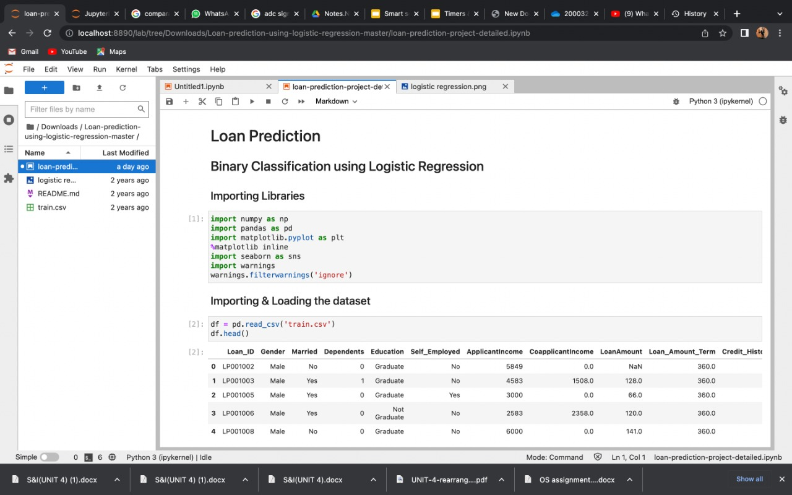

1. **Loading the data set to our file and previewing its 1st five rows.**



1. **Getting the information about our dataset**

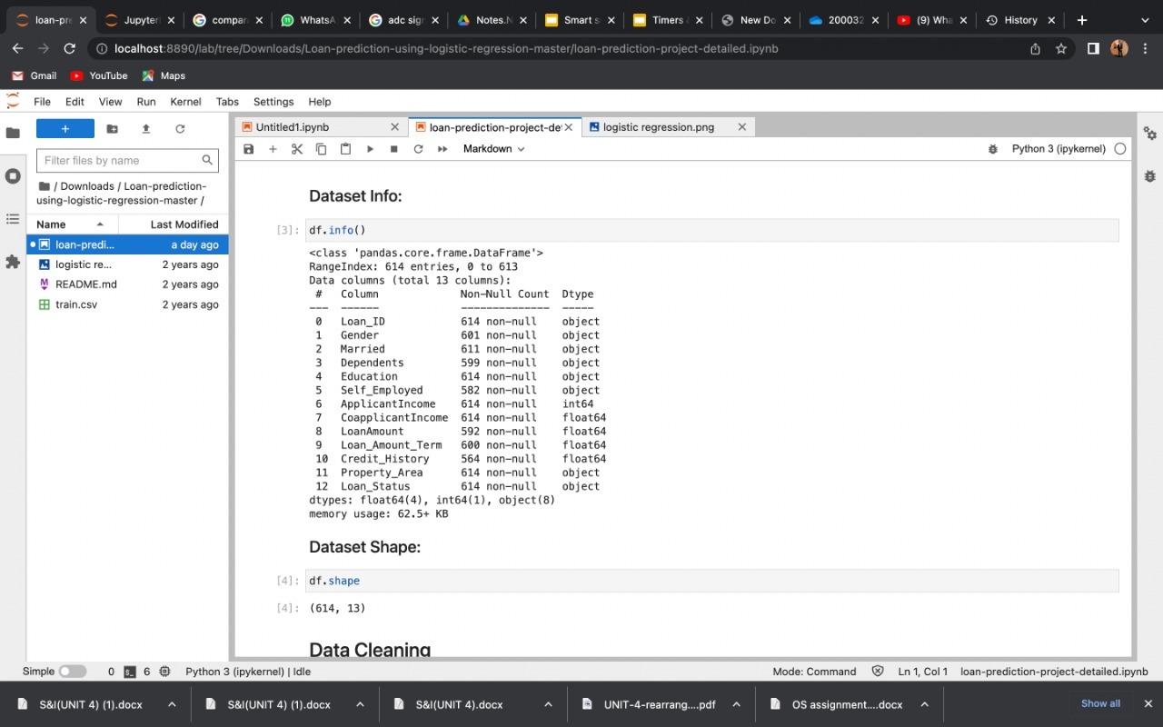

1. **Shape of our dataset.**



1. **Checking the missing values**

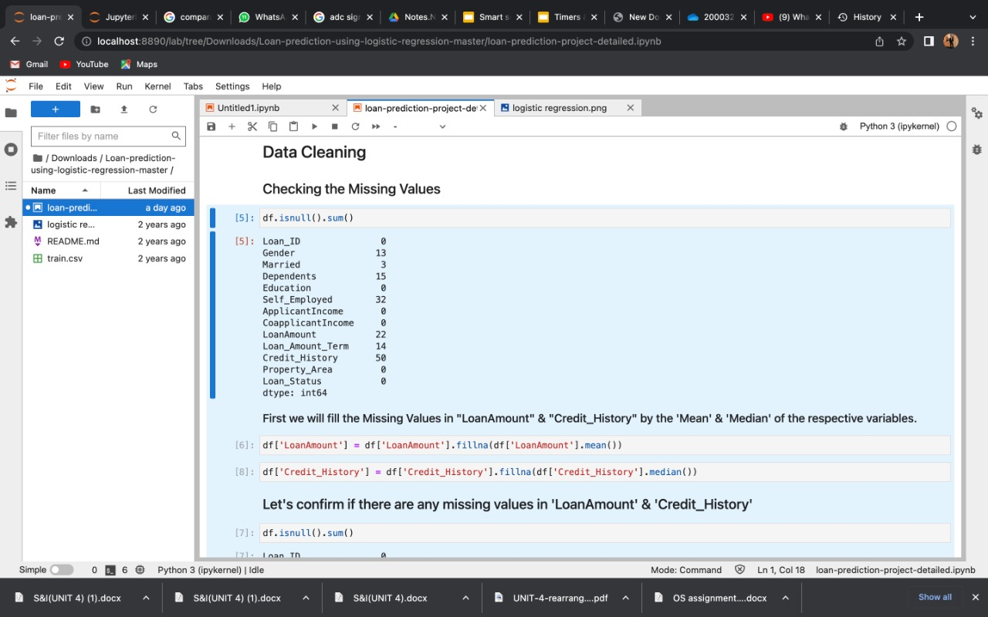



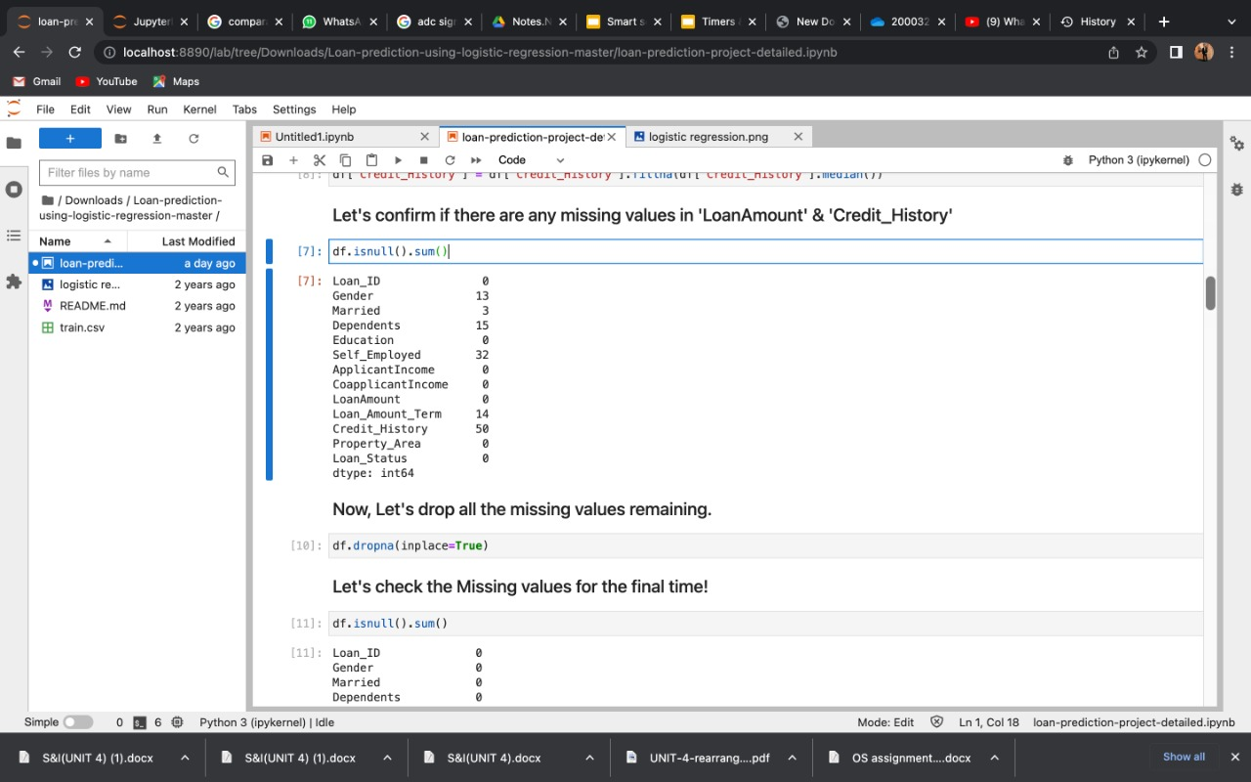





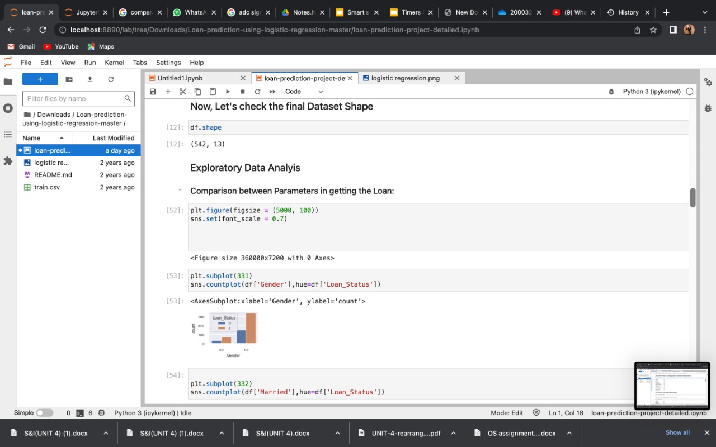

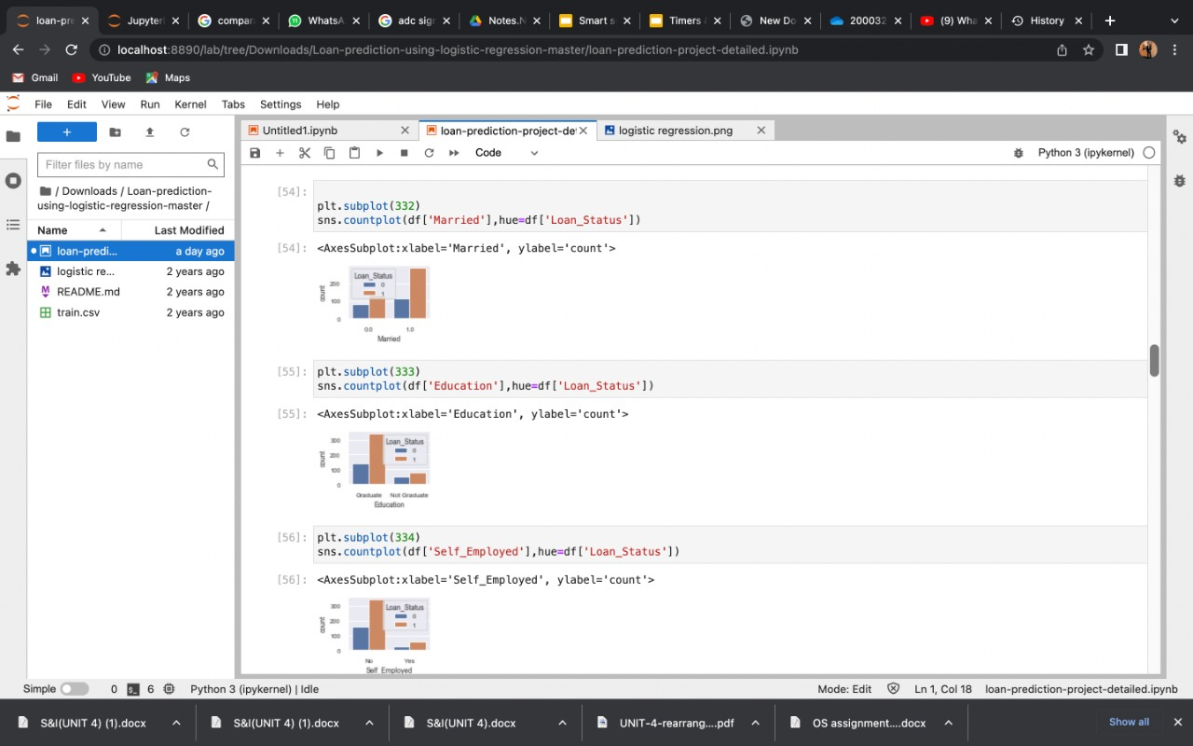

**14.**

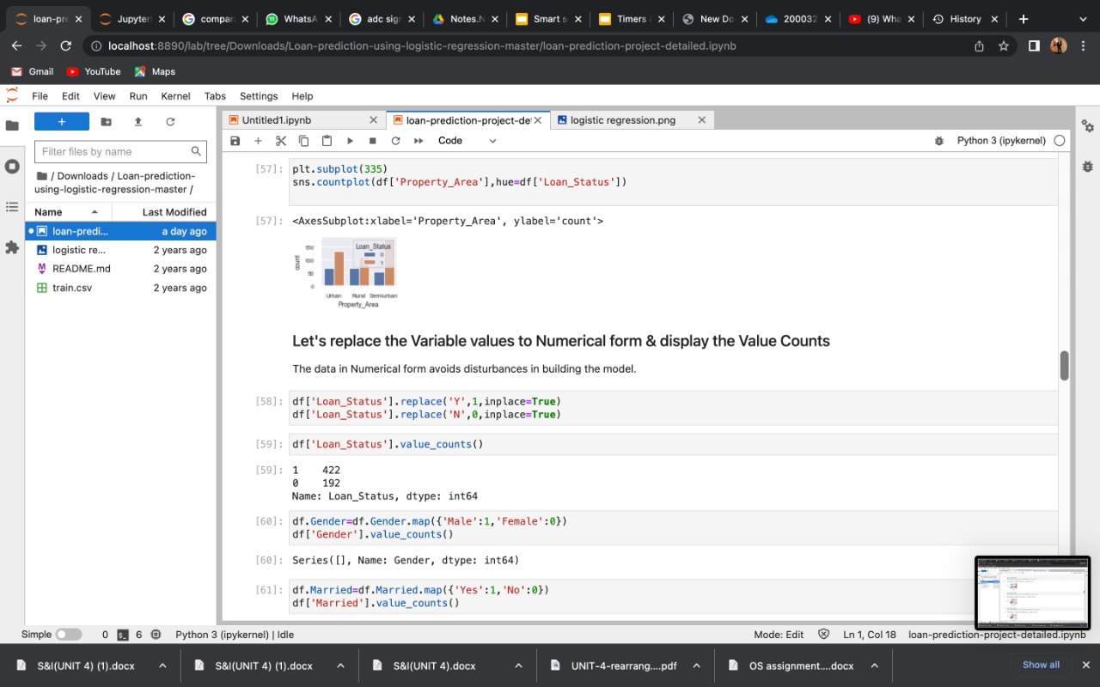 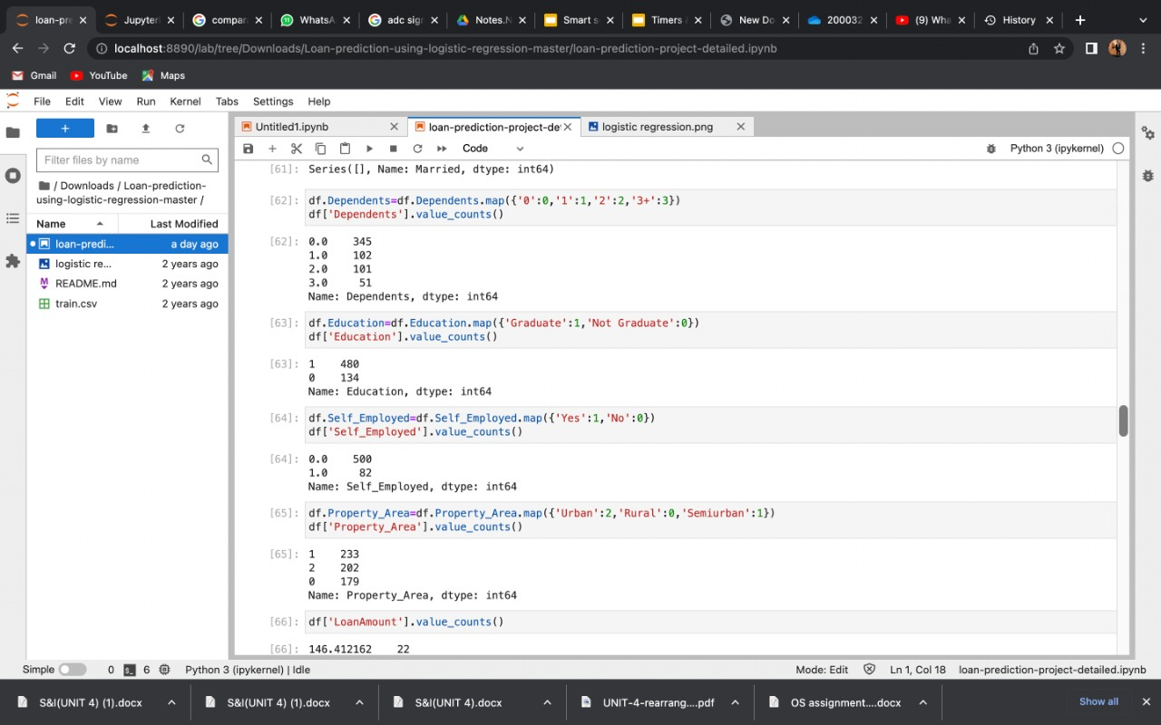

**15.**

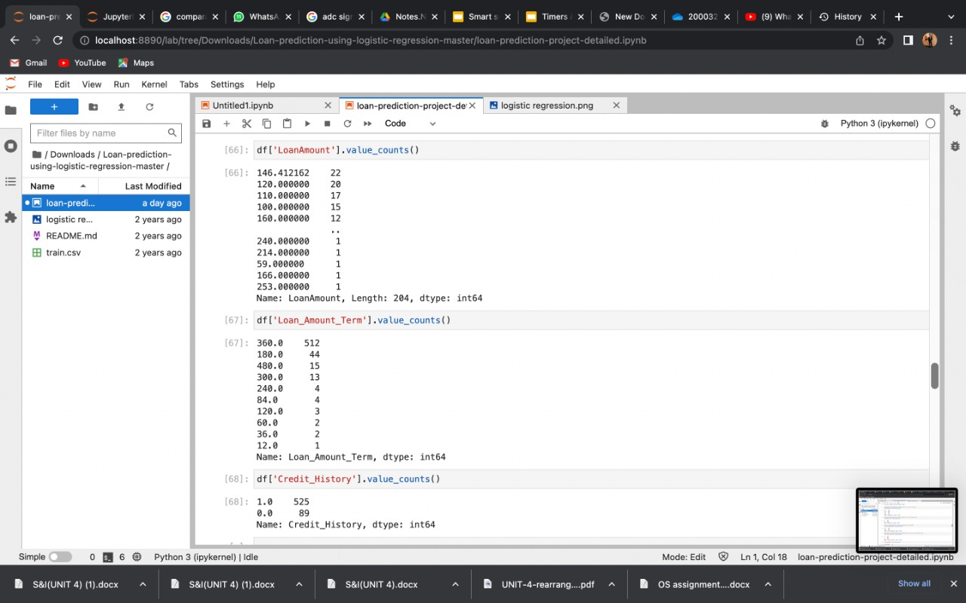

**16.**

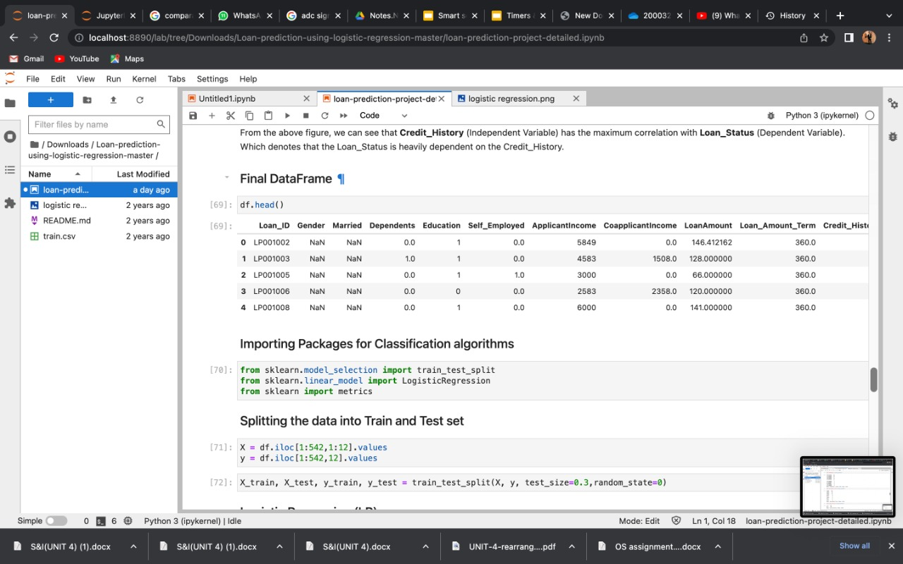

**17.**



**18.**

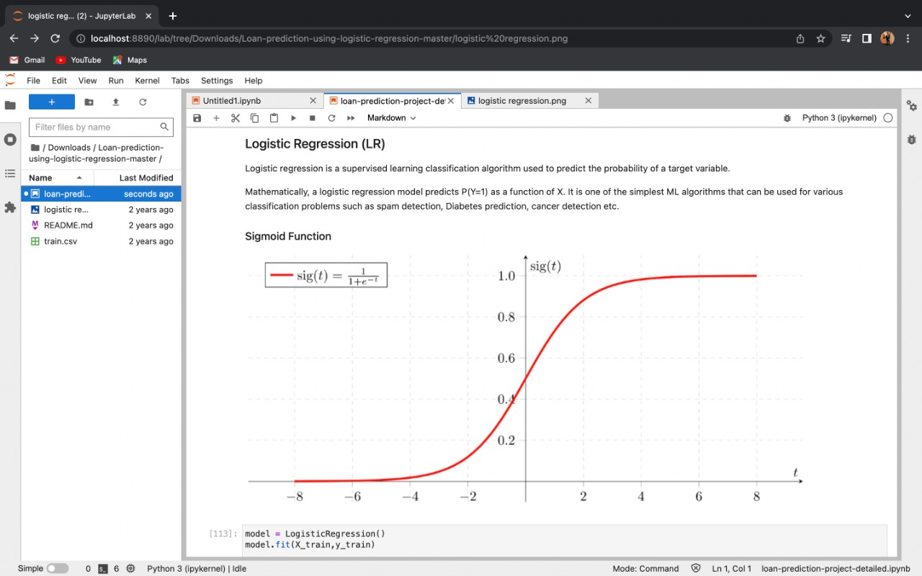

**19.**

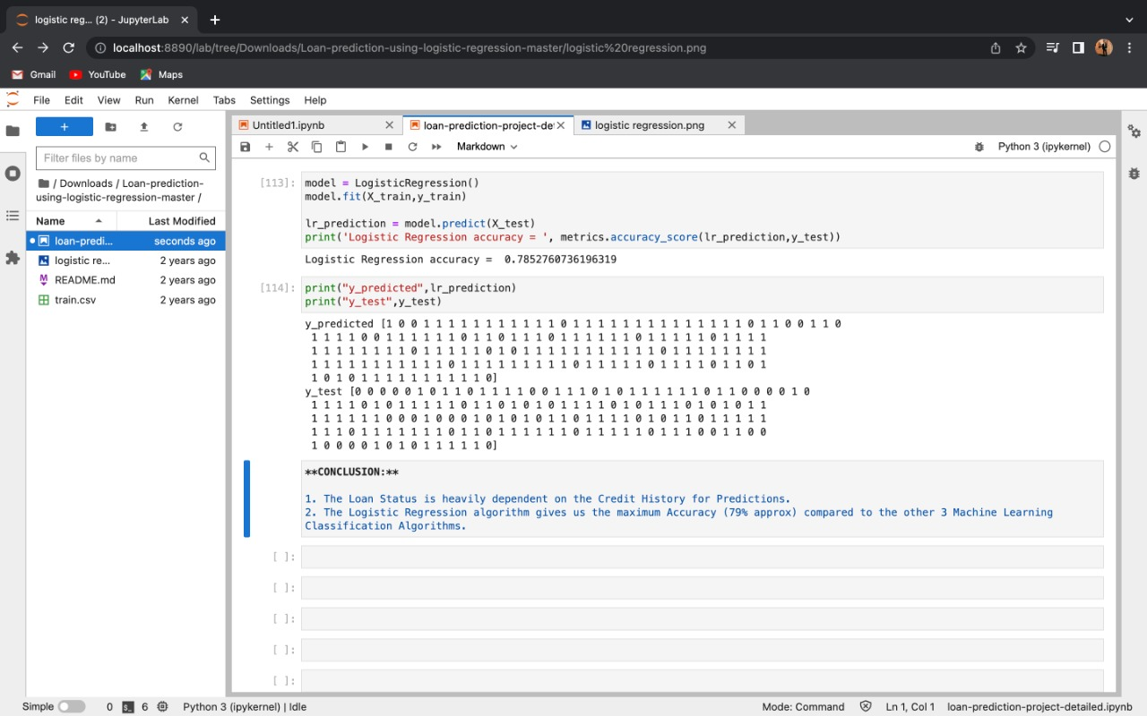

**CONCLUSION:**

1. The loan Status is heavily dependent on the credit History for Prediction.
2. The Logistic Regression algorithm gives us the maximum Accuracy (79% approx) compared to the other 3 Machine Learning Classification Algorithms.